MLA0101 ARTIFICIAL INTELLIGENCE

6. 8 queens problem in Python

print ("Enter the number of queens")

N = int(input())

# here we create a chessboard

# NxN matrix with all elements set to 0

board = [[0]*N for _ in range(N)]

def attack(i, j):

#checking vertically and horizontally

for k in range(0,N):

if board[i][k]==1 or board[k][j]==1:

return True

#checking diagonally

for k in range(0,N):

for l in range(0,N):

if (k+l==i+j) or (k-l==i-j):

if board[k][l]==1:

return True

return False

def N_queens(n):

if n==0:

return True

for i in range(0,N):

for j in range(0,N):

if (not(attack(i,j))) and (board[i][j]!=1):

board[i][j] = 1

if N_queens(n-1)==True:

return True

board[i][j] = 0

return False

N_queens

for i in board:

print (i)

**OUTPUT :**

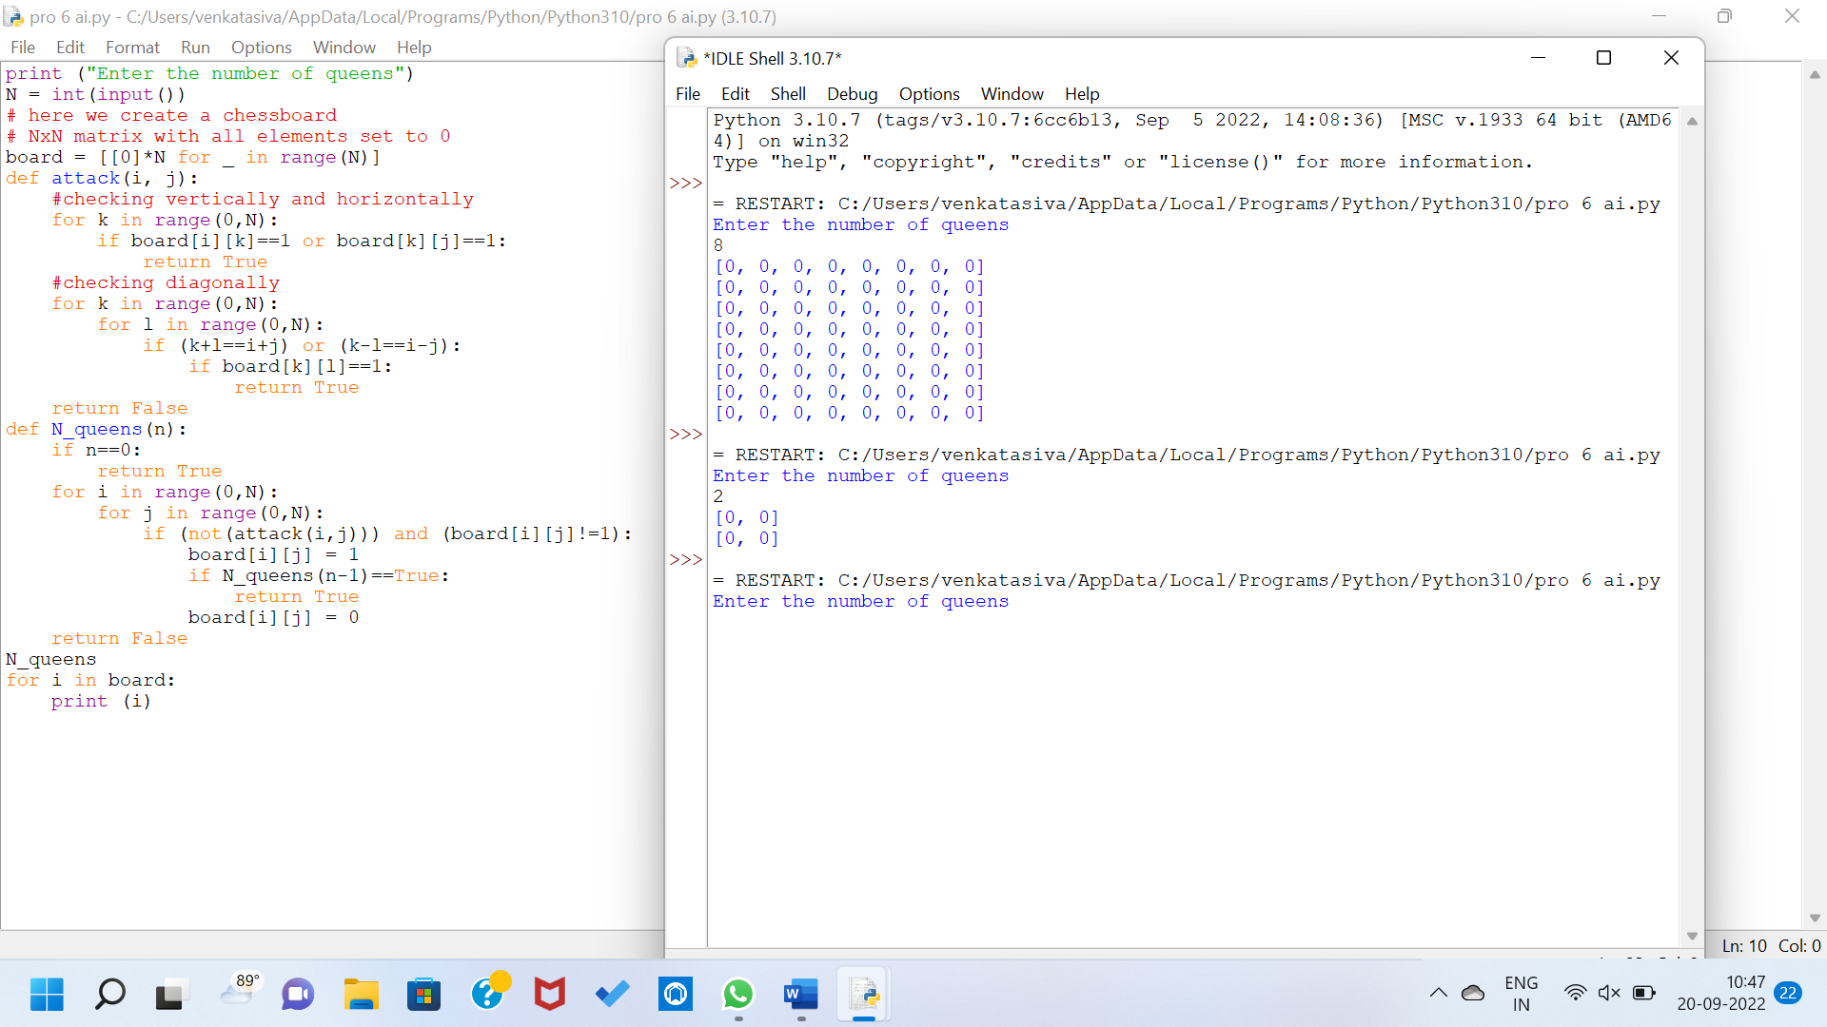

**7.** **Tic-Tac-Toe Game in Python**

**import random**

**class TicTacToe:**

**def _init_(self):**

**self.board = []**

**def create_board(self):**

**for i in range(3):**

**row = []**

**for j in range(3):**

**row.append('-')**

**self.board.append(row)**

**def get_random_first_player(self):**

**return random.randint(0, 1)**

**def fix_spot(self, row, col, player):**

**self.board[row][col] = player**

**def is_player_win(self, player):**

**win = None**

**n = len(self.board)**

**for i in range(n):**

**win = True**

**for j in range(n):**

**if self.board[i][j] != player:**

**win = False**

**break**

**if win:**

**return win**

**for i in range(n):**

**win = True**

**for j in range(n):**

**if self.board[j][i] != player:**

**win = False**

**break**

**if win:**

**return win**

**win = True**

**for i in range(n):**

**if self.board[i][i] != player:**

**win = False**

**break**

**if win:**

**return win**

**win = True**

**for i in range(n):**

**if self.board[i][n - 1 - i] != player:**

**win = False**

**break**

**if win:**

**return win**

**return False**

**for row in self.board:**

**for item in row:**

**if item == '-':**

**return False**

**return True**

**def is_board_filled(self):**

**for row in self.board:**

**for item in row:**

**if item == '-':**

**return False**

**return True**

**def swap_player_turn(self, player):**

**return 'X' if player == 'O' else 'O'**

**def show_board(self):**

**for row in self.board:**

**for item in row:**

**print(item, end=" ")**

**print()**

**def start(self):**

**self.create_board()**

**player = 'X' if self.get_random_first_player() == 1 else 'O'**

**while True:**

**print(f"Player {player} turn")**

**self.show_board()**

**row, col = list(**

**map(int, input("Enter row and column numbers to fix spot: ").split()))**

**print()**

**self.fix_spot(row - 1, col - 1, player)**

**if self.is_player_win(player):**

**print(f"Player {player} wins the game!")**

**break**

**if self.is_board_filled():**

**print("Match Draw!")**

**break**

**player = self.swap_player_turn(player)**

**print()**

**self.show_board()**

**tic_tac_toe = TicTacToe()**

**tic_tac_toe.start()**

OUTPUT :

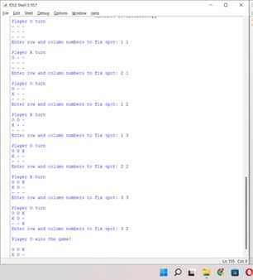

8. To write a python program to implement Travelling Salesman Problem.

***# Python3 program to implement traveling salesman***

***# problem using naive approach.***

***from sys import maxsize***

***from itertools import permutations***

***V = 4***

***# implementation of traveling Salesman Problem***

***def travellingSalesmanProblem(graph, s):***

***# store all vertex apart from source vertex***

***vertex = []***

***for i in range(V):***

***if i != s:***

***vertex.append(i)***

***# store minimum weight Hamiltonian Cycle***

***min_path = maxsize***

***next_permutation=permutations(vertex)***

***for i in next_permutation:***

***# store current Path weight(cost)***

***current_pathweight = 0***

***# compute current path weight***

***k = s***

***for j in i:***

***current_pathweight += graph[k][j]***

***k = j***

***current_pathweight += graph[k][s]***

***# update minimum***

***min_path = min(min_path, current_pathweight)***

***return min_path***

***# Driver Code***

***if __name__ == "__main__":***

***# matrix representation of graph***

***graph = [[0, 10, 15, 20], [10, 0, 35, 25],***

***[15, 35, 0, 30], [20, 25, 30, 0]]***

***s = 0***

***print(travellingSalesmanProblem(graph, s))***

output :

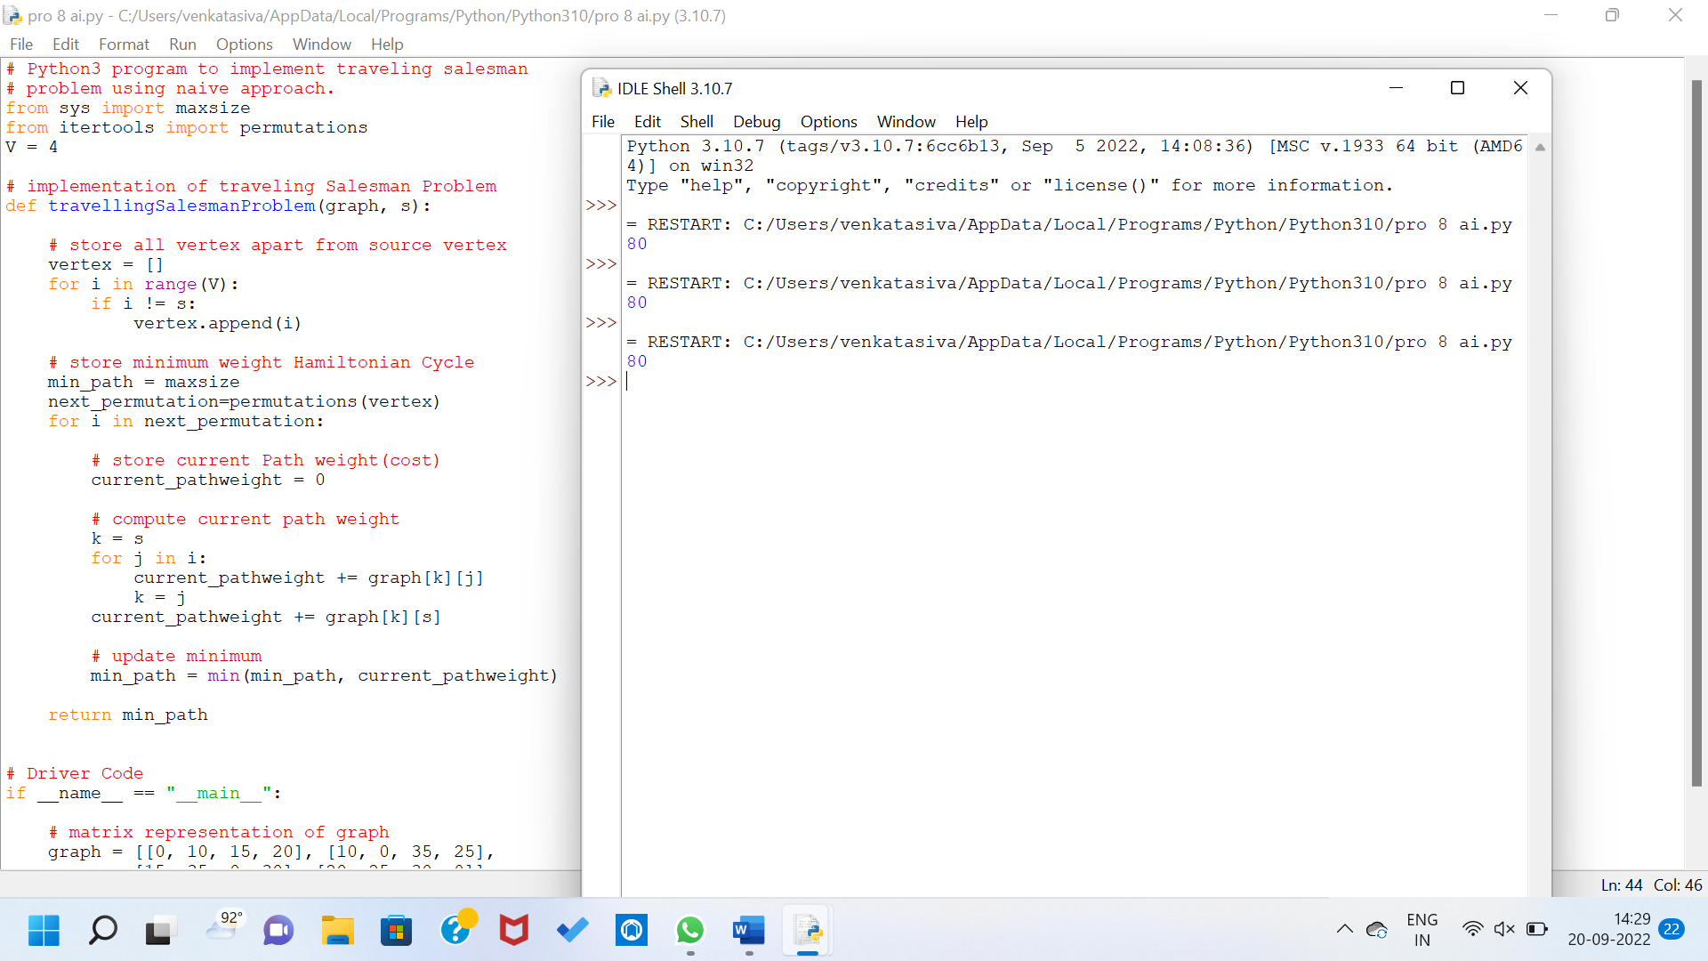

9. write a program to solve tower of hanoi problem in python

**def TowerOfHanoi(n , source, destination, auxiliary):**

**if n==1:**

**print ("Move disk 1 from source",source,"to destination",destination)**

**return**

**TowerOfHanoi(n-1, source, auxiliary, destination)**

**print ("Move disk",n,"from source",source,"to destination",destination)**

**TowerOfHanoi(n-1, auxiliary, destination, source)**

**# Driver code**

**n = 4**

**TowerOfHanoi(n,'A','B','C')**

**# A, C, B are the name of rods**

Output :

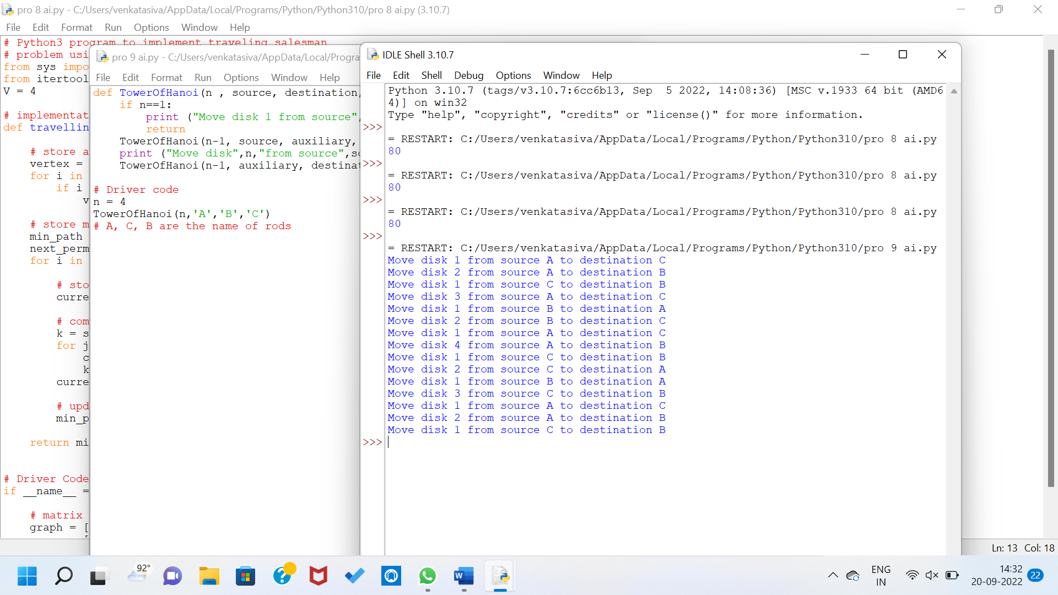

**10. Python Program for 0-1 Knapsack Problem**

**# a dynamic approach**

**# Returns the maximum value that can be stored by the bag**

**def knapSack(W, wt, val, n):**

**K = [[0 for x in range(W + 1)] for x in range(n + 1)]**

**#Table in bottom up manner**

**for i in range(n + 1):**

**for w in range(W + 1):**

**if i == 0 or w == 0:**

**K[i][w] = 0**

**elif wt[i-1] <= w:**

**K[i][w] = max(val[i-1] + K[i-1][w-wt[i-1]], K[i-1][w])**

**else:**

**K[i][w] = K[i-1][w]**

**return K[n][W]**

**#Main**

**val = [50,100,150,200]**

**wt = [8,16,32,40]**

**W = 64**

**n = len(val)**

**print(knapSack(W, wt, val, n))**

**output :**

